Final Project Planning Sheet

**Fan Art Arcade**

* Site Purpose: The purpose of this website is to display examples of my fan-art based, portfolio projects that have entertaining interactions involve. Those who have registered accounts can are allowed the privilege of adding project games of their own.
* Target Audience: The target audience would include men and women ranging between 13 and 35 years of age that have experience in web design and development. These are people who have interactive portfolio projects that they want to share with others.
  + Personas:
  + Daniel – a college freshman who’s had experience with web design all throughout high school. He has a portfolio full of project games and is attaching links to it on all his social media accounts. He wants more ways to share his projects so he can get paid commissions from others and start free-lance work.
  + Isabelle – a high school junior who just got interested in web design/computer programming. She was told doing personal projects is a good way to develop skills beyond the classrooms’ scope. She looks online for fun example projects and idea suggestions that she would be interested in.
* Site Map
  + 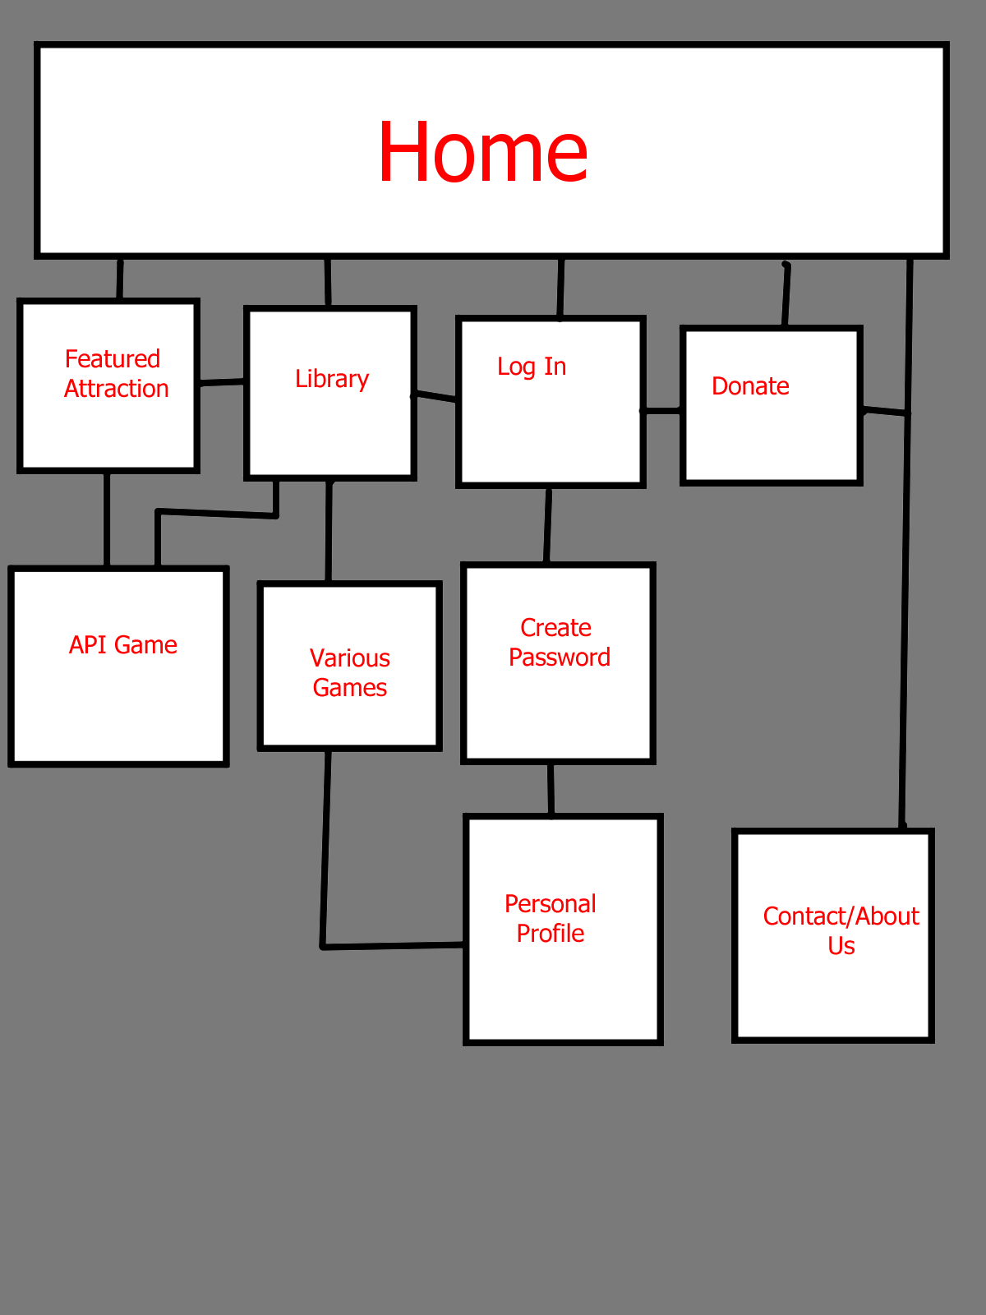

Color Scheme:

* 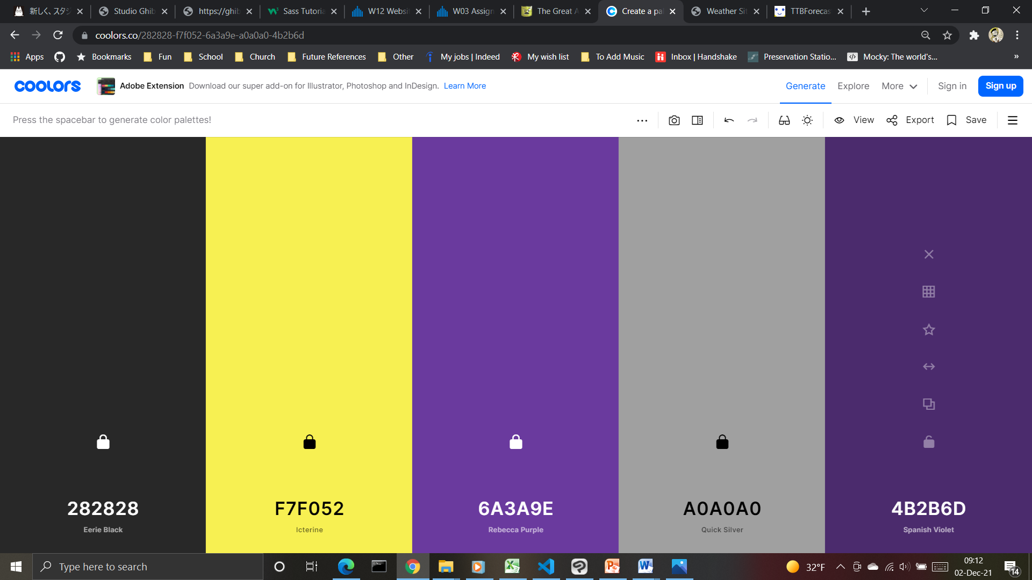
  + Header #6A3A9E
  + Nav #A0A0A0
  + Footer #4B2B6D
  + Body #282828
  + Header Font #F7F052 or #FF910C
* Typography:
  + Headings: PT Serif (Italic)
  + Normal Text: Arial

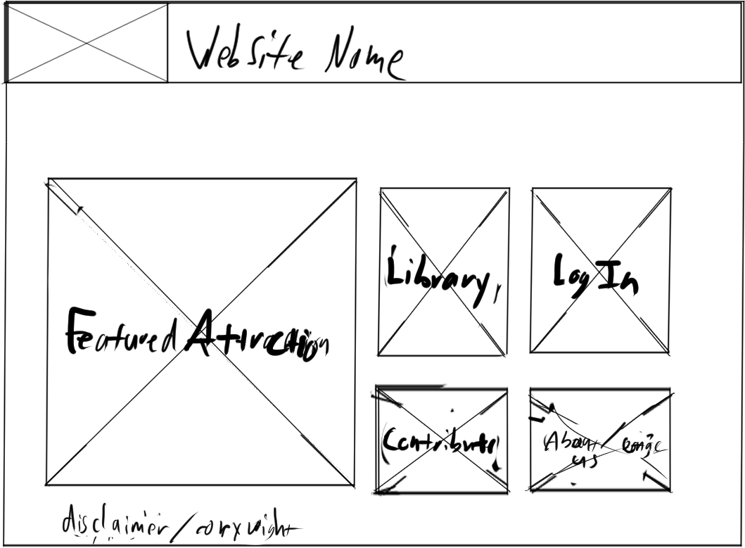

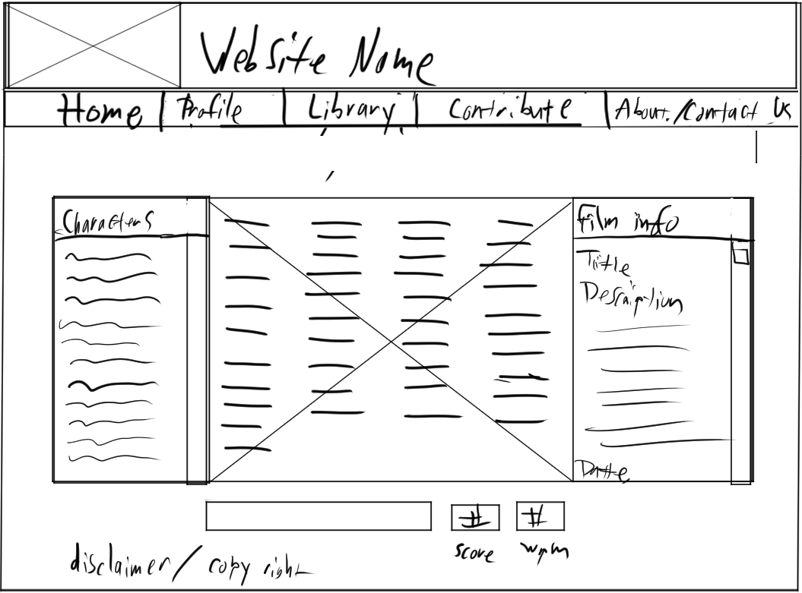

Featured Attraction (Full)

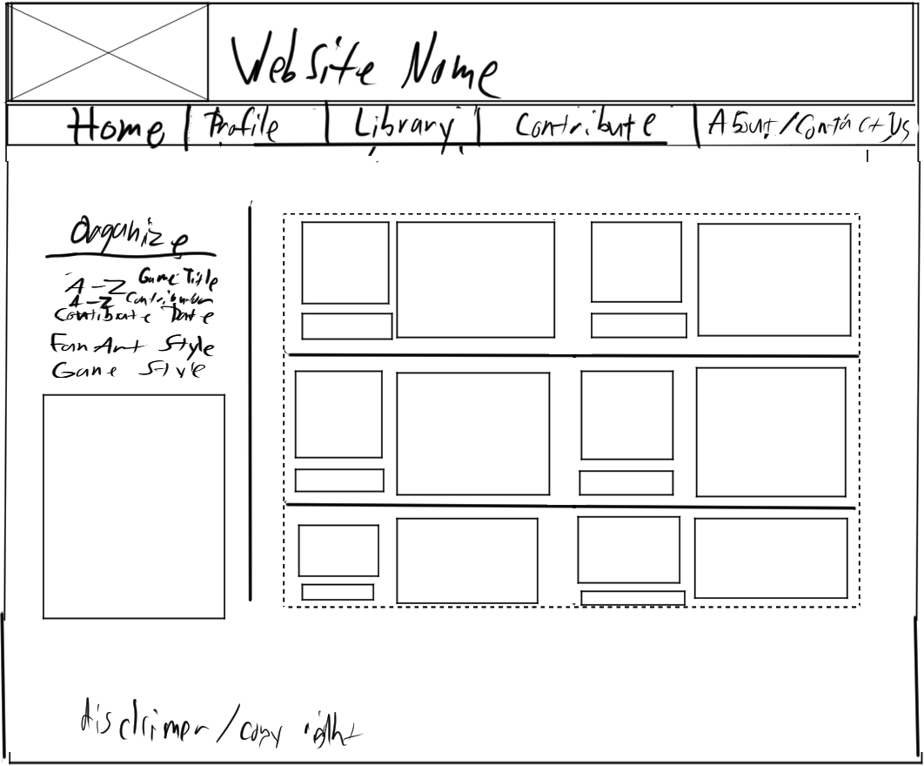

Library (full Screen)

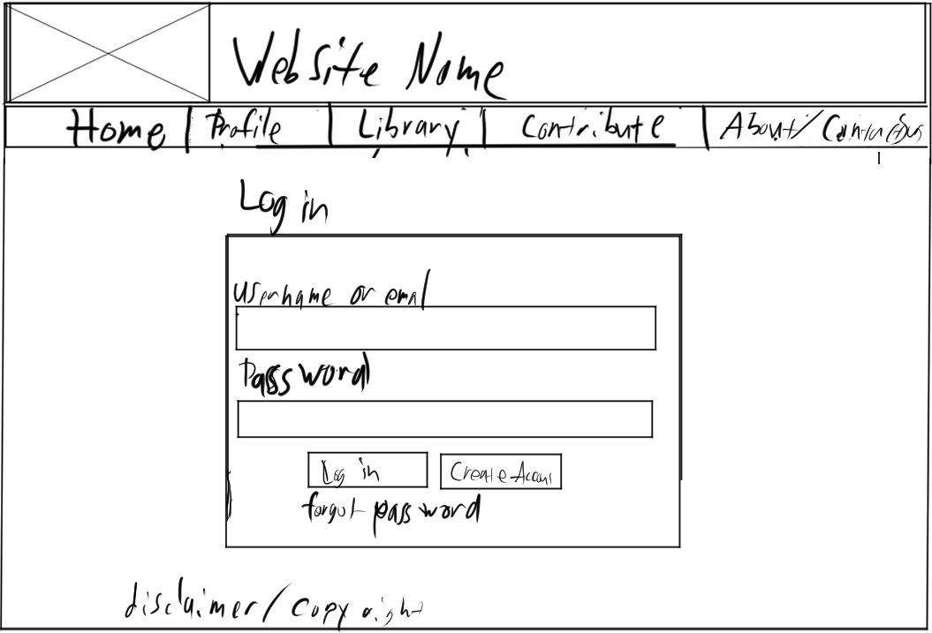

Log-in (Full)

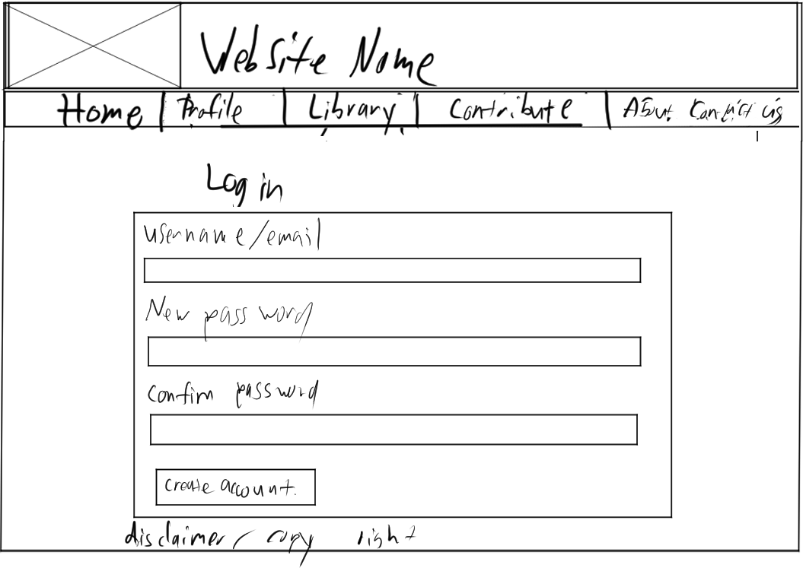

Create Account (Full)

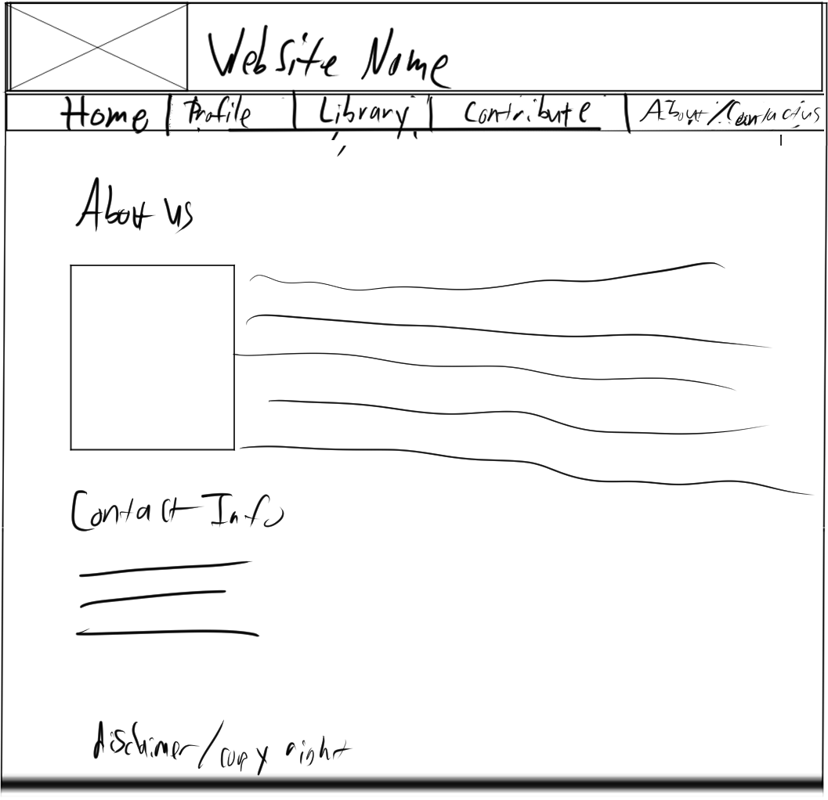

Contact/About us (full)

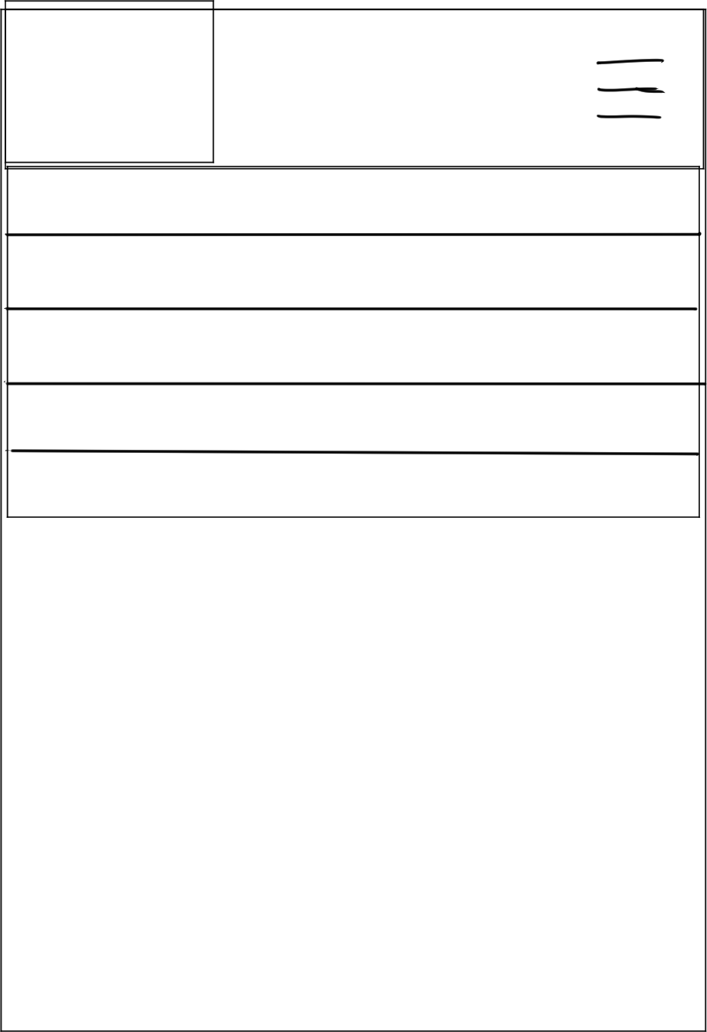

Nav (small)

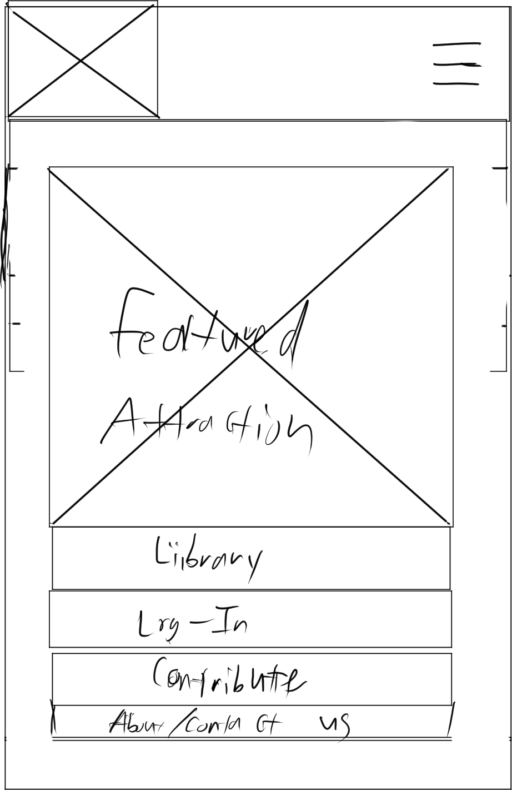

Home (Small)

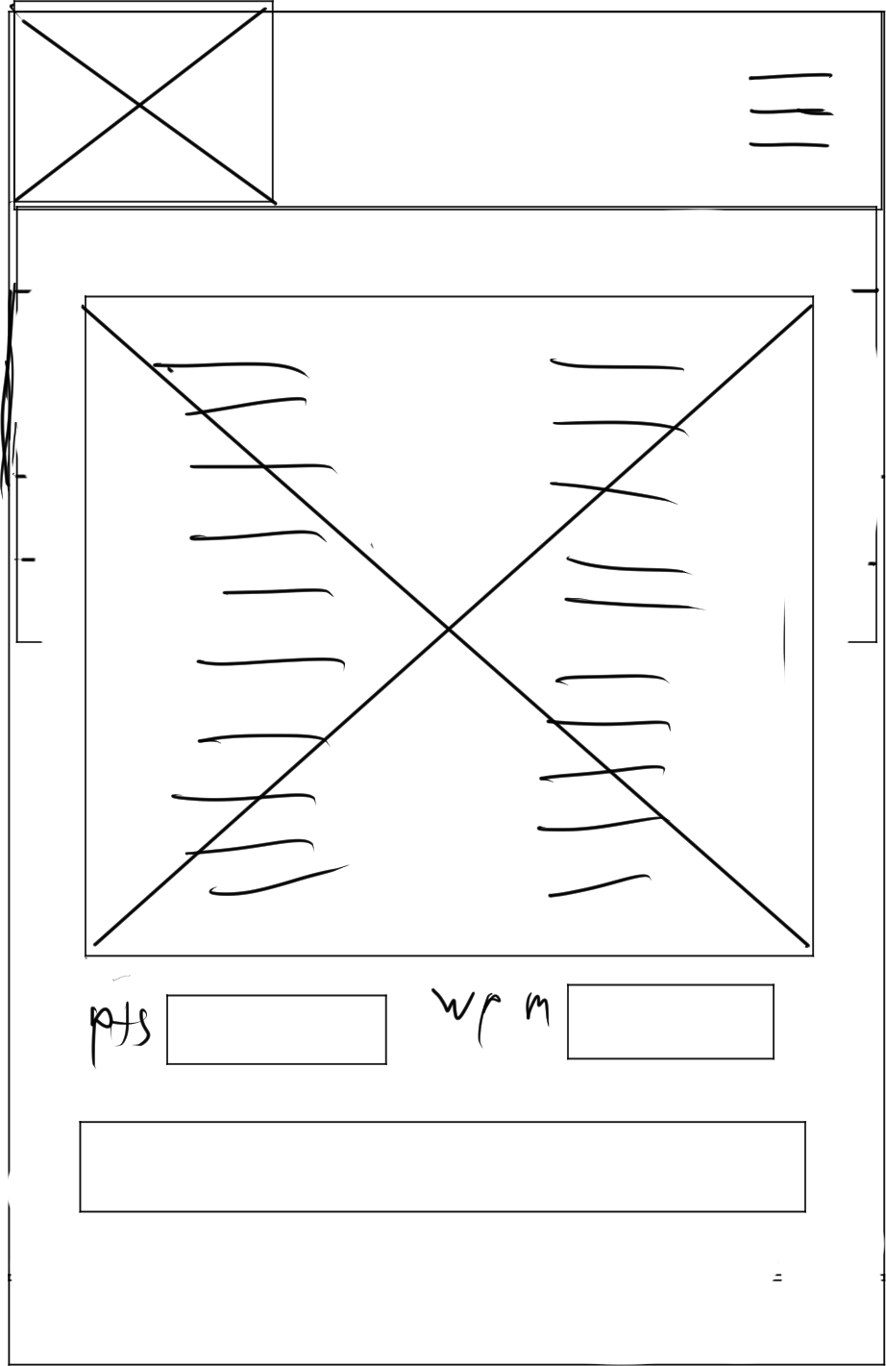

(Fetured Game: Small )

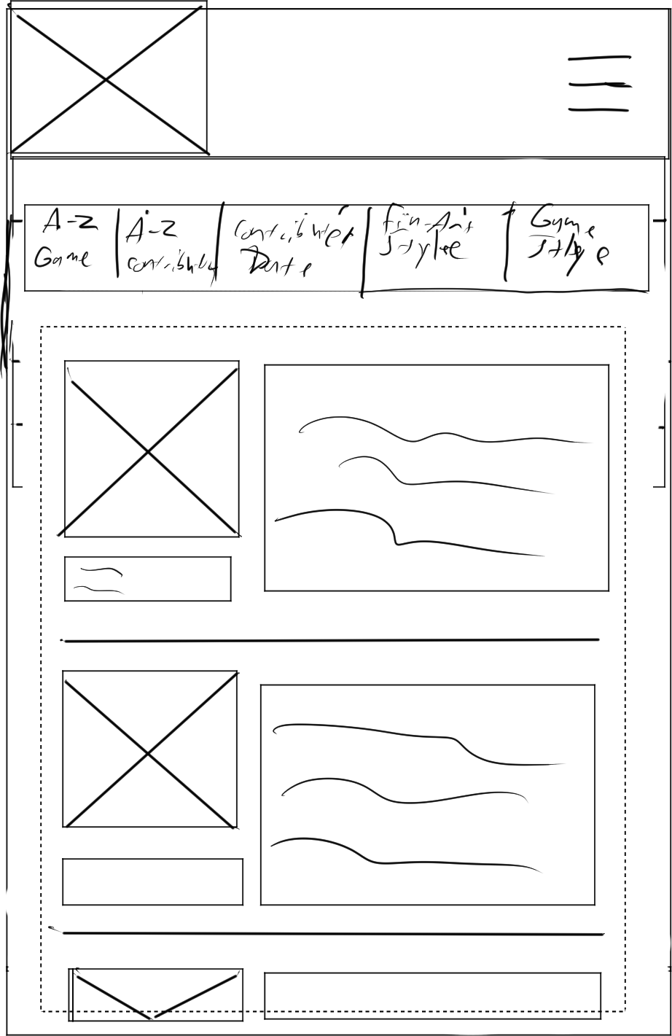

Library (Small)